Jeroen Koopmans, s1852310

**The use of species distribution modelling to determine climate change-driven range shifts in *Phoenix dactylifera***

**Introduction**

Date palm (*Phoenix dactylifera*) has been an important fruit crop in large parts of the Middle East, the Arabian Peninsula, and North Africa, with evidence suggesting their cultivation has already occurred in these regions for around 5000 years (Zohary and Hopf, 2000). During this time, dates have proven to be crucial staple foods, often shaping the local economy and environment around them. This specifically for *P. dactylifera*, as its fruit is considered sweeter than that of other species (Zaid and deWet, 2002). Since then, they have been successfully introduced into different parts of the world, including Australia, North- and South America and parts of Europe.

A member of the Palmae family (Arecaceae), the species is frequently found in tropical and subtropical areas, where the heat is necessary for fruit forming. Although the plants are most comfortable at 26 - 45°C, they can tolerate a much wider range of temperatures, of 10°C up to 52°C. It also prefers a mean annual precipitation of around 200-300mm, but can tolerate ranges of 100-400mm.

As for now, these conditions are met in their areas of occurrence, naturally or with the help of irrigation. However, climate change can have a multitude of consequences in the future (Sala et al., 2000). As such, it can be expected that some of these areas may not prove to be hospitable anymore. What this means in terms of actual locations for the species can be hard to predict.

This is where SDM will come in quite useful. Species distribution modelling, or SDM, is considered a powerful method to predict the possible impacts of climate change on the geographic distributions for target species based on environmental data and future Global Climate Model (GCM) outputs ([Booth, 2018](https://www-sciencedirect-com.ezproxy.leidenuniv.nl:2443/science/article/pii/S0304380019303254#bib0090); [Guisan et al., 2013](https://www-sciencedirect-com.ezproxy.leidenuniv.nl:2443/science/article/pii/S0304380019303254#bib0340); [Thuiller et al., 2015](https://www-sciencedirect-com.ezproxy.leidenuniv.nl:2443/science/article/pii/S0304380019303254#bib0730)). This will make it possible to predict the exact geographic distributions based on a number of likely scenarios.

This leads us to the central research question:

-What are the predicted changes on the geographic distribution of *P. dactylifera*, under intermediate conditions of climate change? Hypothesis hereby is that the range will shift away from the equator, as temperature changes will be the highest in these regions.

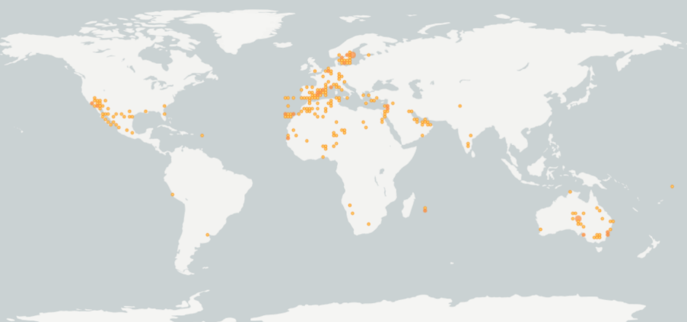**Methodology and Results**

***Occurrences***

Occurrence data is drawn from GBIF (<https://www.gbif.org/>), an organization aimed at the gathering and sharing of occurrence data of a very wide selection of organisms.

The data will be selected to only include human observations, as to eliminate any form of error. These may be comprised of wrongly interpreted coordinates, placing observations for example in the middle of the ocean; or fossils, which would potentially have different ranges than their current counterparts.

As seen in Fig.01, a total of 1288 data points were available for the species. Its distribution spans parts of North America, Australia and Europe, even presenting itself as far north as Sweden. So far, no spatial biases seem to be present, and locations are likely correct for the species’ actual niche. This data can subsequently be loaded into RStudio.

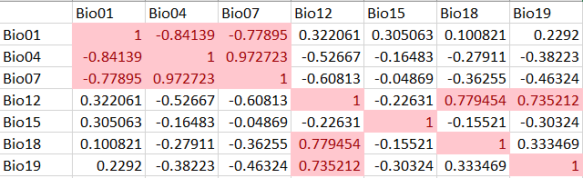***Environmental data***

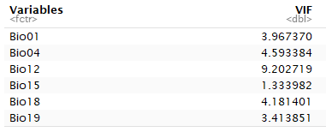As far as environmental data goes, a few variables were picked thought to be relevant for ecological modelling. These included Annual Mean Temperature(1), Temperature Seasonality(4), Temperature Annual Range(7), Annual Precipitation(12), Precipitation Seasonality(15), Precipitation Warmest Quarter(18), and -Coldest Quarter(19). Of these, number 7 was eventually dropped due to high values during multicollinearity testing. The new values can be seen in Fig.02. These new variables were used in MAXENT.

**

***Model output***

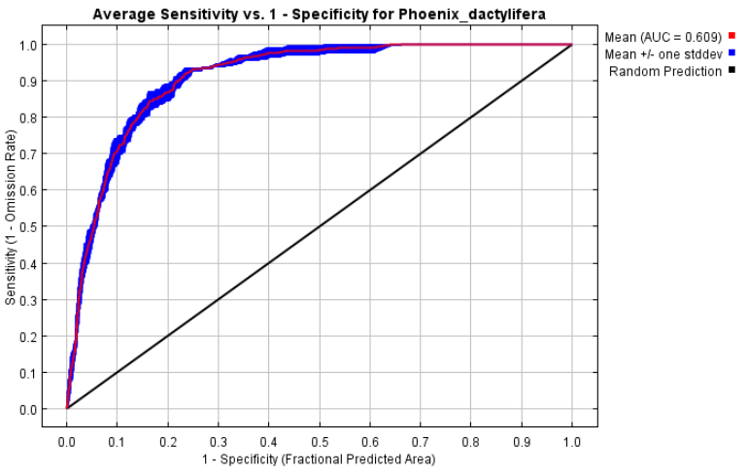The first result coming from MAXENT is the ROC-curve. With an AUC of 0.609, the curve seems to represent an accurate model (Fig.03).

This can also be recognised in the variable importance, as almost all variables seem to have contribution to the model.

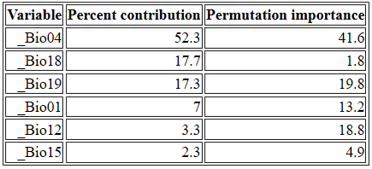



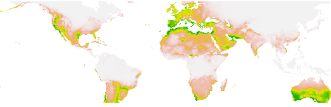***SDM Projections***

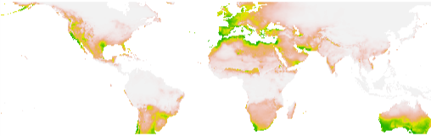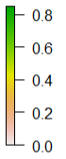After loading these data into R, they were turned into maps showing both present and future (RCP4.5) scenarios (Fig.04). As a means of better recognising the differences in distribution, a subsequent contrast map was also constructed.

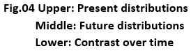When comparing the top maps, a few differences can be seen. These include the loss of potential area in parts of the Arabian Peninsula, North- and South America, and Australia. In addition, France seems to grow as potential habitat when compared to Spain, although not enough to warrant a significant difference on the contrast map. A small increase in potential territory can also be seen along the south coast of Alaska, however chances are slim that *Phoenix* will ever be able to reach these locations on their own.

**Discussion and Conclusion**

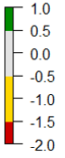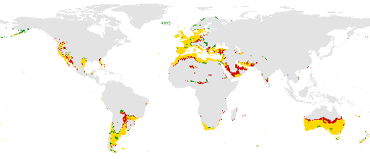When tested against the future RCP4.5 scenario, *Phoenix dactylifera* showed some major areas of potentially lost territory. All of these losses are oriented towards the equator, whereas its gains are focussed towards the northwards (sub)arctic areas. This seems to prove that an increased risk of desertification (as momentarily going on in the United States and Spain) and climate change-driven temperature rise may pose a threat to *P. dactylifera*. This in turn also confirms the hypothesis.

It can also be argued that this is only an intermediate scenario, in which Greenhouse Gas concentrations more or less halt from 2050 onwards, which would mean the worse scenarios would potentially have truly grave consequences.

All in all, MAXENT did very well in its predictions, and shows good promise for future use. However, more research should be done to fully understand its potential. This would also include running with more of the RCP-scenarios, and with more species whose distributions might be less clearly explained using climate change.

**Citations**

-Booth, T.H., 2018. Species distribution modelling tools and databases to assist managing forests under climate change. For. Ecol. Manage. 430, 196–203. https://doi.org/10.1016/j.foreco.2018.08.019

-Guisan, A., Tingley, R., Baumgartner, J.B., Naujokaitis-Lewis, I., Sutcliffe, P.R., Tulloch, A.I.T., Regan, T.J., Brotons, L., Mcdonald-Madden, E., Mantyka-Pringle, C., Martin, T.G., Rhodes, J.R., Maggini, R., Setterfield, S.A., Elith, J., Schwartz, M.W., Wintle, B.A., Broennimann, O., Austin, M., Ferrier, S., Kearney, M.R., Possingham, H.P., Buckley, Y.M., 2013. Predicting species distributions for conservation decisions. Ecol. Lett. 16, 1424–1435. https://doi.org/10.1111/ele.12189

-Sala, O.E., Chapin III, F.S., Armesto, J.J., Berlow, E., Bloomfield, J., Dirzo, R., HuberSanwald, E., Huenneke, L.F., Jackson, R.B., Kinzig, A., Leemans, R., Lodge, D.M., Mooney, H.A., Oesterheld, M., Poff, N.L., Sykes, M.T., Walker, B.H., Walker, M., Wall, D.H., 2000. Global biodiversity scenarios for the year 2100. Science 287, 1770–1774

-Thuiller, W., Pollock, L.J., Gueguen, M., Münkemüller, T., 2015. From species distributions to meta-communities. Ecol. Lett. 18, 1321–1328. https://doi.org/10.1111/ele.12526

-Zaid A and deWet PF (2002). Origin, Geographical Distribution and Nutritional Value of Date Palm In: Date Palm Cultivation (Zaid A, ed.). Food and Agricultural Organization of the United Nations, Rome

-Zohary, D. and M. Hopf. 2000. Domesticationof plants in the old world: The origin andspread of cultivated plants in West Asia,Europe, and the Nile Valley. Oxford UniversityPress, Oxon, UK.1082HORTSCIENCEVOL. 42(5) AUGUST2007

-https://www.gbif.org/

-http://tropical.theferns.info/viewtropical.php?id=Phoenix+dactylifera

-http://worldclim.org/

